1.
Create a table named MusicPlaylist with columns: id, song_name, artist, genre, and duration. Insert at least 5 records representing songs from your favorite Spotify playlist, then write a SELECT statement to retrieve all columns for all songs.
CREATE TABLE MusicPlaylist (
id INT PRIMARY KEY,
song_name VARCHAR(100),
artist VARCHAR(100),
genre VARCHAR(50),
duration TIME
);
INSERT INTO MusicPlaylist (id, song_name, artist, genre, duration) VALUES
(1, 'Blinding Lights', 'The Weeknd', 'Pop', '00:03:20'),
(2, 'Bohemian Rhapsody', 'Queen', 'Rock', '00:05:55'),
(3, 'Hotel California', 'Eagles', 'Rock', '00:06:30'),
(4, 'Levitating', 'Dua Lipa', 'Pop', '00:03:23'),
(5, 'Shape of You', 'Ed Sheeran', 'Pop', '00:03:53');
SELECT * FROM MusicPlaylist;

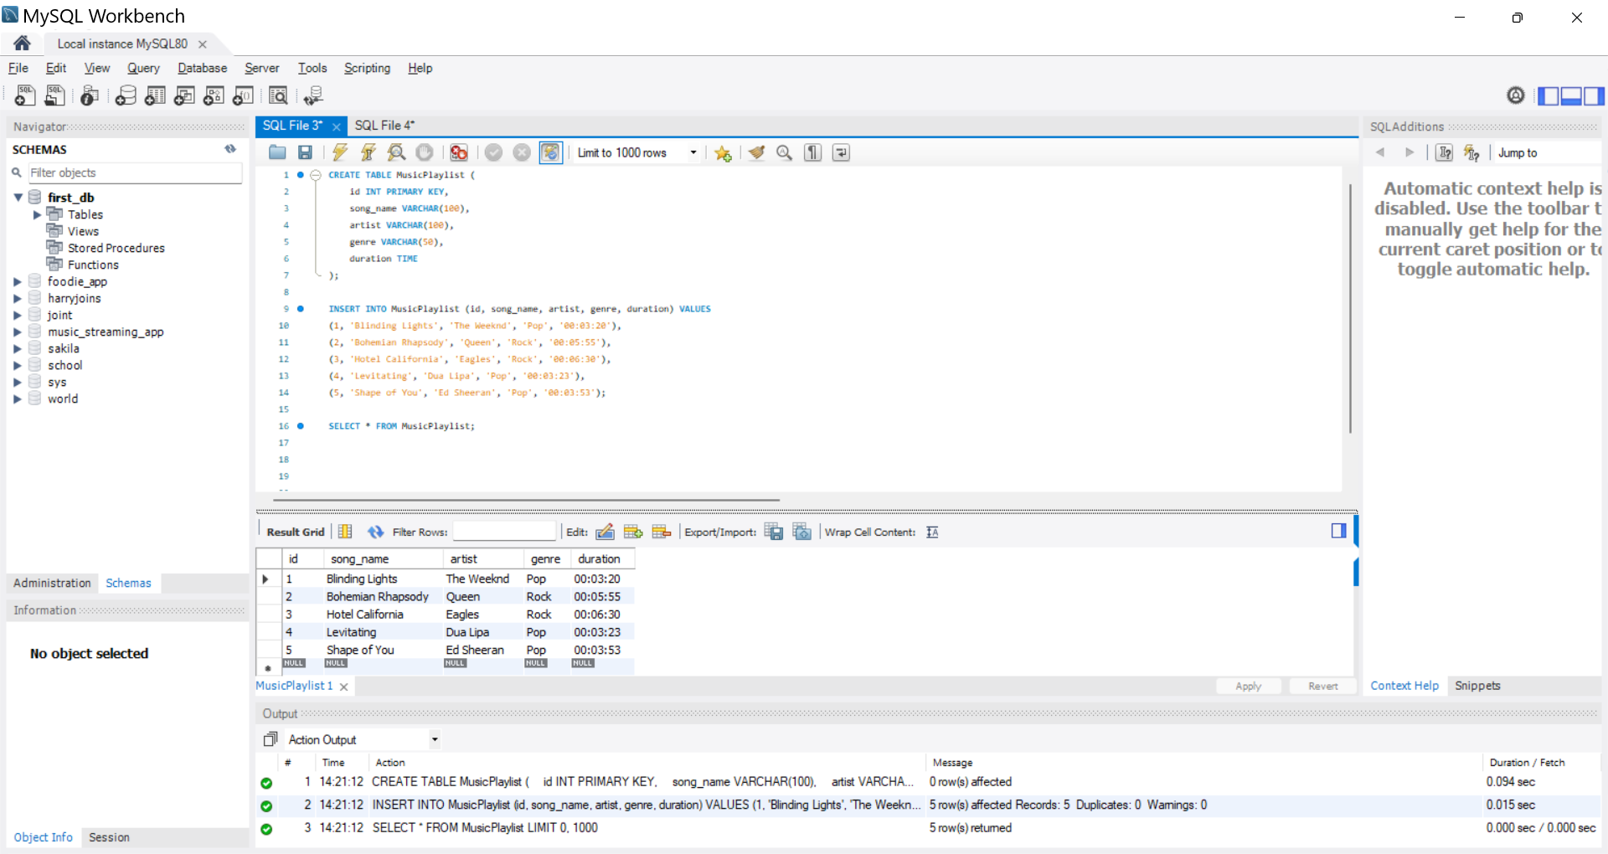
2.
Write a SQL query to display only the song_name and artist columns from the MusicPlaylist table, showing just the first 3 records using the LIMIT keyword.
SELECT song_name, artist
FROM MusicPlaylist
LIMIT 3;
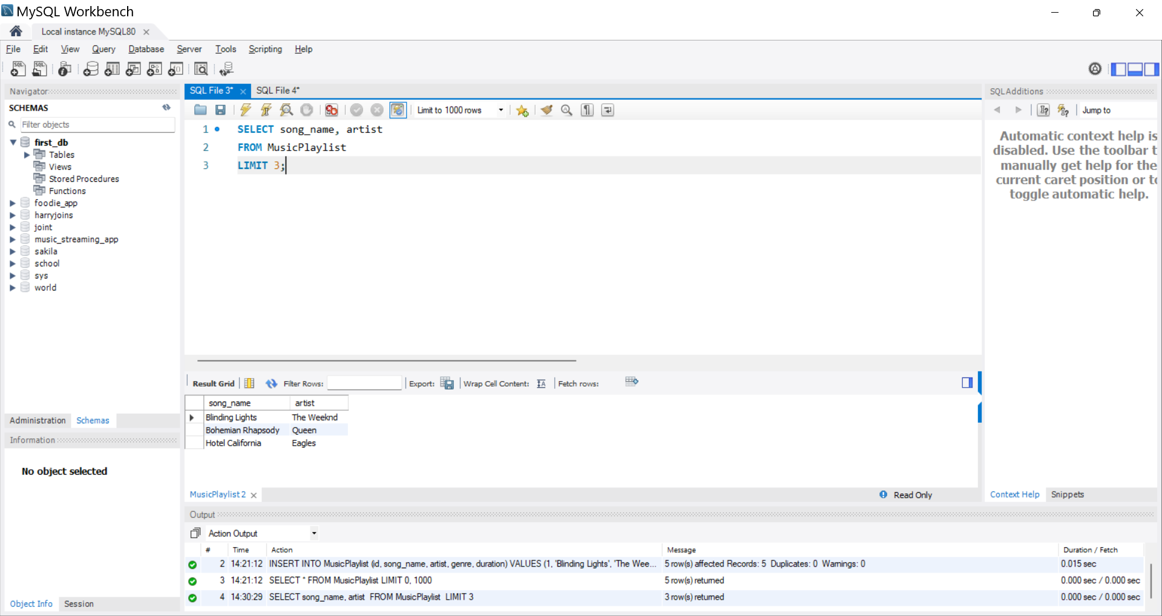

3.
Suppose you have a table named FoodOrders with columns: id, restaurant, food_item, and order_date. Write a SQL query to list all unique restaurant names where you have placed orders, using the DISTINCT
CREATE TABLE FoodOrders (
id INT PRIMARY KEY,
restaurant VARCHAR(100),
food_item VARCHAR(100),
order_date DATE
);
INSERT INTO FoodOrders (id, restaurant, food_item, order_date)
VALUES
(1, 'Burger King', 'Whopper Meal', '2026-09-01'),
(2, 'Pizza Hut', 'Pepperoni Pizza', '2026-09-05'),
(3, 'Burger King', 'French Fries', '2026-09-10'),
(4, 'Taco Bell', 'Bean Burrito', '2026-09-12'),
(5, 'Pizza Hut', 'Buffalo Wings', '2026-09-15'),
(6, 'Subway', 'Tuna Sub', '2026-09-16');
SELECT DISTINCT restaurant
FROM FoodOrders;
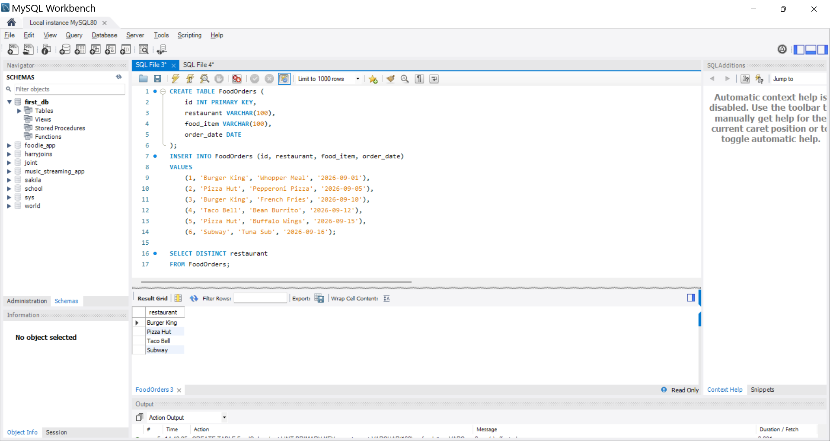
4.
Write a SQL query on the FoodOrders table to select food_item as 'Dish' and order_date as 'Date Ordered', displaying only these two columns with the column aliases in the output.
SELECT food_item AS 'Dish', order_date AS 'Date Ordered'
FROM FoodOrders;
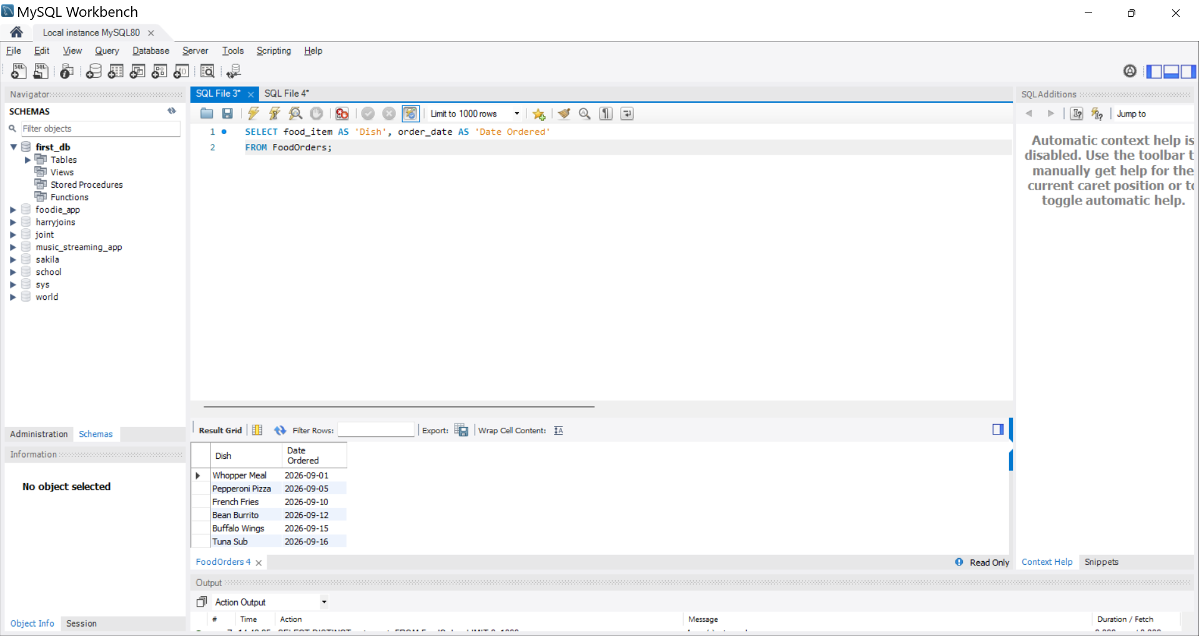

5.
You tried running this query: SELECT DISTINCT food_item, restaurant FROM FoodOrders LIMIT 2, but it returns an error or doesn't work as expected. Identify and fix the mistake in the query.<br><br><em><strong>Hint:</strong> Check the correct placement and usage of the LIMIT keyword in SQL syntax.</em>
While SELECT DISTINCT food_item, restaurant FROM FoodOrders LIMIT 2; is syntactically correct in MySQL and PostgreSQL, it is considered poor practice and will yield unpredictable results.
The Mistake: Using LIMIT without an ORDER BY clause means the database engine will return any 2 random rows that satisfy the DISTINCT condition. The order of rows in a relational database is never guaranteed unless explicitly sorted.
The Fix: Always pair LIMIT with an ORDER BY clause placed immediately before it so you know exactly which 2 records you are retrieving.
SQL
SELECT DISTINCT food_item, restaurant
FROM FoodOrders
ORDER BY restaurant, food_item
LIMIT 2;

5.
You tried running this query: SELECT DISTINCT food_item, restaurant FROM FoodOrders LIMIT 2, but it returns an error or doesn't work as expected. Identify and fix the mistake in the query.<br><br><em><strong>Hint:</strong> Check the correct placement and usage of the LIMIT keyword in SQL syntax.</em>

